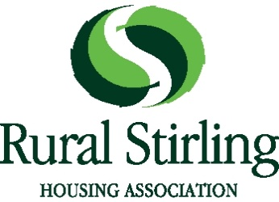

Application Form for Membership
Rural Stirling Housing Association is a Registered Social Landlord. We are a registered society under the Co-operative and Community Benefit Societies Act 2014 and a Scottish Charity. Membership is open to people who are interested in supporting our activities – our membership policy explains who can apply.
If you would like to apply to become a Member, please complete this form and send it to: The Secretary, Rural Stirling Housing Association Ltd, Stirling Road, Doune FK16 6AA.
You must enclose £1 with your application which will purchase your ‘share’ if your application is successful (it will be returned if not).

Full Name
Address
Post Code
Are you over 16?
E-mail
Telephone number

Are you a tenant or a resident of Rural Stirling Housing Association?
YES NO

Are you related to an employee or Member of the Board of Management of RSHA? YES NO
(If yes, please say who )
Are you a member of any other housing association or co-operative? YES NO
(if yes, please state which )
Please say why you want to join RSHA and which aspects of our work you are especially interested in

I apply to become a member of Rural Stirling Housing Association and enclose £1 as payment for a Share.

Signed: Date:

Decisions about Membership are made by the Board of Management. To be eligible to vote at the 2022 AGM, your application for membership must be received not later than 11th August 2022.

