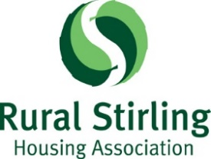

DIVERSITY & EQUAL OPPORTUNITIES MONITORING

Rural Stirling Housing Association is committed to equal opportunities in employment, regardless of age, disability, gender reassignment, marriage & civil partnership, pregnancy & maternity, race (including colour, nationality ethnic or national origins and citizenship), religion/belief, sex and sexual orientation.

To help us monitor our Equality & Diversity Policy and the effectiveness of our recruitment practices, we would like you to answer the following questions. You are under no obligation to answer any of the questions.

Any information provided will be treated in the strictest confidence, in line with the requirements of data protection legislation and will not be shared with the Interview Panel

Position applied for: HOUSING SERVICES ADVISER

1. Are you: Male Female Trans Gender

2. Which of the following age bands do you belong to?

16-24 years 25-34 years 35-44 years
45-55 years 55 & over

3. Do you consider yourself to have a disability/special needs?

Yes No

4. Ethnic Origin: Please choose ONE section from A to E, then tick the appropriate box to indicate your cultural background.

A White B Mixed C Asian or Asian British D Black or Black British

English Any mixed Indian Caribbean
Scottish background Pakistani African
Welsh Bangladeshi Other Black
Irish Other Asian
Polish Chinese
Gypsy Traveller
Other White

E other ethnic group Prefer not to say

Arab, Arab Scottish/British

5. Specify your religion:___________________________________

None Prefer not to say

6. Sexual Orientation
Would you describe yourself as (please tick):

Heterosexual Lesbian Gay Bisexual Prefer not to say

Thank you for your co-operation

