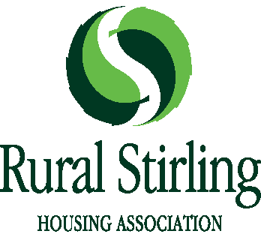
Eligibility Declaration
Please confirm your eligibility to be considered as a prospective member of Rural Stirling Housing Association’s Board of Management by ticking the “I Agree” box; if you are unable to confirm any of the statements, please provide details:
 | I Agree | Comments/Details
You are not an undischarged bankrupt
You have not entered into an arrangement with your creditors
You have not been convicted of a crime of dishonesty for which the statutory rehabilitation period has not expired
You have not been convicted of an offence under the Charities and Trustee Investment (Scotland) Act 2005
You are not party to any legal proceedings in any Court of Law by or against Rural Stirling Housing Association or Venachar
You have not been removed from the governing body of another RSL within the last five years
You have not resigned from the Governing Body at any time during the last five years after receiving notice that a special committee meeting was to be held to consider your removal
You have not been removed from the Governing Body during the last five years
You have not been removed or suspended from a position of management or control of a charity under the provisions of the Law Reform (Miscellaneous Provisions) (Scotland) Act 1990 of the Charities and Trustee Investment (Scotland) Act 2005
You have not been removed from the office of Charity Trustee or trustee for a charity by the Charity Commissioners in England or Wales or by the High Court of Justice
You are not the subject of a Disqualification Order or have had a disqualification undertaking made against you
You are not related to a member of the Governing Body of RSHA or Venachar

Name and signature of member being nominated

Date _________________

