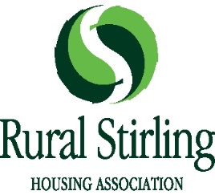

DIVERSITY & EQUAL OPPORTUNITIES MONITORING FORM

To help us monitor our Equal Opportunities Policy please answer the following questions. You are under no obligation to answer any of the questions.

All information will be treated in the strictest confidence, in line with the requirements of data protection legislation.

Gender: Female □ Male □ Trans Gender □

Ethnic Origin: Please choose ONE section from A to E then tick the appropriate box to indicate your cultural background.
A White B Mixed C Asian or Asian D Black or Black
Scottish/British Scottish/British
□ English □ any mixed □ Indian □ Caribbean
□ Scottish background □ Pakistani □ African
□ Welsh □ Bangladeshi □ other black
□ Irish □ Chinese
□ Polish □ Other Asian
□ Gypsy Traveller
□ Other white

E Other ethnic group
□ Arab, Arab Scottish/British □ Prefer not to say

Disability: Do you consider yourself to have a disability? By this we mean a condition which has a long term and substantial effect on your ability to carry out normal day to day activities. □ Yes □ No
If yes, is it:

Physical □ Mental Ill Health □ Learning Disability □
Visual Impairment □ Hearing Impairment □ Other □ – please specify

……………………………………………………………………………………………………………

Age: Please indicate your age group.
□ 16-24 □ 25–34 □ 35-44 □ 45-54 □ 55-64 □ 65 and over

Sexual Orientation:

□ Bi-sexual □ Gay/Lesbian □ Heterosexual/Straight □ Prefer not to say

Religion: I would describe my religious background/belief

as…………………………………………… □ None □ Prefer not to say

