Alterations and Improvements Form | 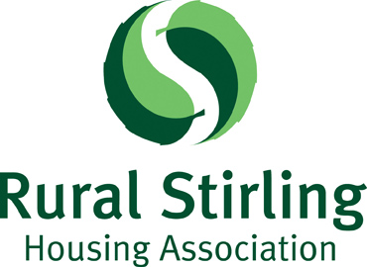

1. Address of property to be altered/improved:
2. Email Address:
3. Full Name(s) of Tenant/Sharing Owner:
4. Details of proposed alteration/improvements:
Please provide full details. Include plans, specification, estimates, etc. Continue on separate page if necessary and attach relevant documents to this form.)

5. Is Planning Permission or a Building Warrant required? Yes No
If yes, please attach or enclose copies of the approval.
6. Signature(s):

7. Date:
Please return this form to the Property Services Officer. Email enquiries@rsha.org.uk or post to RSHA, Stirling Road, Doune, FK16 6AA.

You should not proceed with the alteration until you have received permission from RSHA to do so.

For office use only

Post Inspection carried out: ……………………………………………….

Is work to a satisfactory Standard: Yes ….. No …..

Signature of Property Services Officer: ……….………………………

